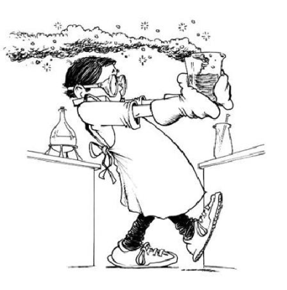**1.1 Science Lab Safety**

* _________________________________.
  + _______ and _________ the safety rules.
* Know what to do in an _____________.

**Science Lab Rules. General.**

* All ___________, written and verbal, about laboratory procedures MUST be followed.
* Know the location and proper use of _____________________.
* Equipment or supplies should NOT be handled without ________________. UNAUTHORIZED EXPERIMENTS ARE FORBIDDEN.
* Act _____________. Failure to do so will result in your permanent removal from science labs.
* Safety equipment, including _________ and ___________, must be worn during every lab.
* Hair and loose clothing must be ______________.
* Each lab station must be kept _____ and ________ at all times.
* There is absolutely NO ________, ________, or ________ allowed during labs.
* Never use ___________ glassware.

**Science Lab Rules. Chemicals.**

* Wash any affected areas immediately with water and _______________________.
* If you get anything in your eyes, wash them continuously for ____ minutes.
* Never ________ a substance directly, waft the fumes towards your nose.
* Hold containers away from ________ when pouring liquids.
* Never put any chemical back into its _________________. Only put chemicals down the ________ or into the _________ with permission.

**Science Lab Rules. Hot Plates.**

* Use ____________ containers only.
* Do not allow a container to ________________.
* Be careful with a hot plate that looks as though it has ___________________.

**Science Lab Rules. Open Flames.**

* Wear _____________________. Tie back long hair and loose clothing.
* Handle _______________carefully (they may look cool).
* Point the open end of container that is being heated away from ____________________.
* Turn off __________________________ as soon as you are finished using them.
* Apply ___________________ to burns.

**Science Lab Rules. Electrical Equipment.**

* Make sure your hands are _______ when touching electrical cords, plugs or sockets.
* Pull the ________, not the cord.
* Report __________________________ to your teacher.
* Place electrical cords where people will not _________ over them.

**Science Lab Rules. WHMIS Symbols.**

* _______________________________________________________________ (WHMIS)
* A method of ensuring everyone has access to appropriate safety information about any substance they may encounter that is manufactured or sold.
* WHMIS is a system of ___ symbols.

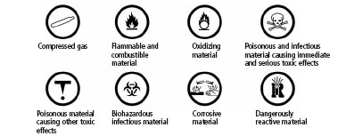

**Science Lab Rules. Other Safety Symbols.**

* Hazard symbols can be found on a variety of commercial products.
* There are two kinds of warnings:

Hazards.

Boarders.

dangercontainExplosiveFlam

Flammable

Dangerous Container

Explosive

Corrospoisondangerprod

Corrosive

Dangerous Product

Poisonous

**1.2 Investigating Matter.**

* 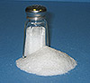Matter is anything that has ­­­­­______ and __________.
  + Mass is the _______ of ______ in a substance or object.
  + Mass is often measured in _____ or ____________.
  + Volume is the _______ of _________ a substance or an object occupies.
  + Volume is often measured in _________.

**Chemical Change.**

* A ________________ is a change in matter that occurs when substances combine to _________________________.

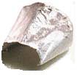

Salt

NaCl

Chlorine

Cl­2 (Gas)

Sodium

Na (Solid)

**Physical Change and Changes of State.**

* 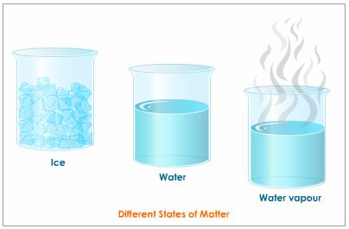When a ________________ occurs, there may be a change in appearance, but ______________________ are formed.
* For example, when ice or snow melts to water, this physical change is a change of state. No new substances are formed.

**The Particle Model of Matter.**

* Describes the ___________________________.
* Matter is made of _____________________.
  + There are ___________ between the particles.
    - ________ have more space than _______. _______ have more space that __________.
* 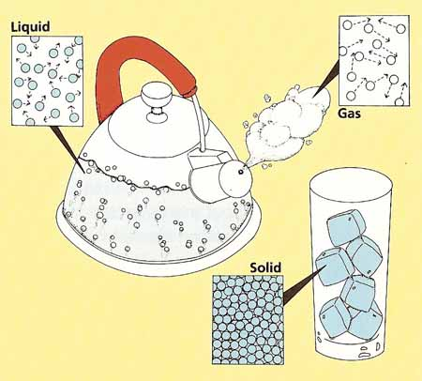Particles are always __________.
* Particles are __________ to each other. The _________ of

attraction depends on the ___________ of particle.

**The Kinetic Molecular Theory.**

* Describes what happens to matter when the _________________ of particles changes.

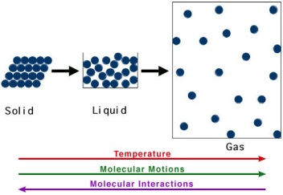The main points in the theory are:

* Matter is made of ________________.
* There is ______________ between particles.
* Particles are constantly __________.
* __________ makes particles move.
* _________ particles are _______________ and cannot move freely. They can only _________.
* _________ particles are _____________ and can _______________________.
* _______ particles are far apart and _______________________.

**___________**

* 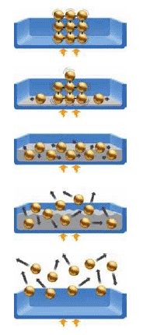Particles are close together, fixed in position and vibrating.

**___________**

* As temperature increases, particles’ kinetic energy increases.

**___________**

* Particles are still close, but slide past one another.

**___________**

* As temperature increases, particles’ kinetic energy continues to increase,

creating more space.

**___________**

* Particles are highly energetic and moving freely.

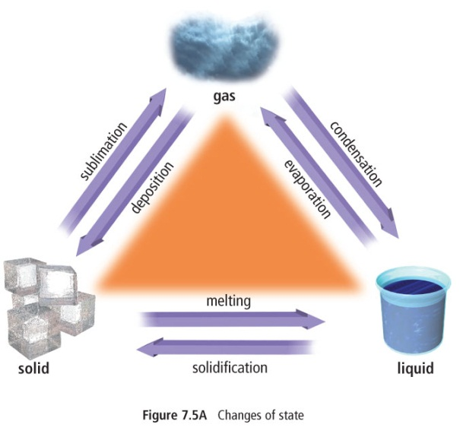**Temperature and Changes of State.**

* When ________is ____________ to a substance, it’s particles gain kinetic energy and vibrate faster. This causes them to move farther apart.
* **_______________** is the change of state from a **___________** to ________ (popsicle melting)
* **________________** (freezing) is the change of state from a____________ to a **____________** (pond freezing)
* **_______________** is the change of state from a **____________** to a **_______** (sweating)
* **___________________** is the change of state from a **________** to a

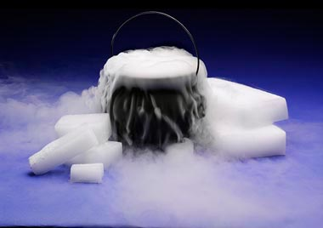**______________** ( dew forming on lawn)

* **_______________** is the change of state from a

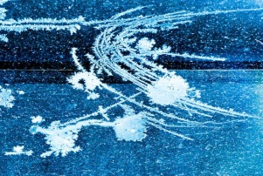 **_________** to a **___________** (dry ice)

* **_________________** is the change of state from

a **________** to a **____________** (frost forming)

**Describing Matter.**

* Physical Properties
  + Qualitative – non-numerical
    - state, colour, malleability
  + Quantitative – numerical
    - conductivity, viscosity,

density

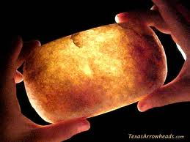**Qualitative Properties.**

* _______________ is the physical state the

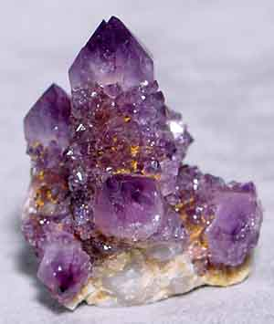matter is in: SOLID, LIQUID or GAS.

* _______________ refers to the COLOUR

of the matter.

* _______________ refers to the SHAPE and

STRUCTURE (soft, hard, rough, smooth).

* _______________ refers to the ability for light to

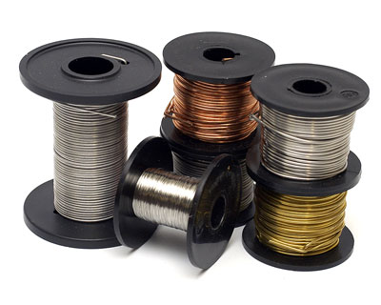 pass through matter (opaque, translucent, transparent).

* _______________ refers to the SHAPE or

APPEARANCE of CRYSTALS.

* 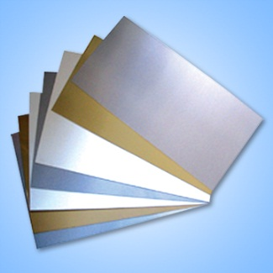_______________ refers to the ability of the matter

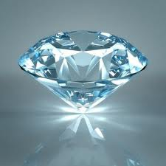to be BEATEN into SHEETS.

* _______________ refers to the ability to be

DRAWN into WIRES. _______________ refers to the

REFLECTIVENESS of an object.

* 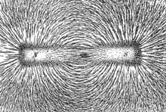_______________ refers to the tendency of

matter to be ATTRACTED to a MAGNET.

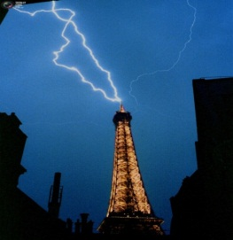**Quantitative Properties.**

* 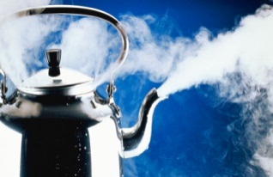_______________ refers to the ability

to DISSOLVE in WATER.

* _______________ refers to the ability

to CONDUCT ELECTRICITY or HEAT.

* _______________ refers to the RESISTANCE of FLOW.
* _______________ is the RATIO of the object’s MASS to its VOLUME.
* _________________________________ is the TEMPERATURE at which melting/freezing will occur.
* _________________________________ is the TEMPERATURE at which boiling/condensing will occur.

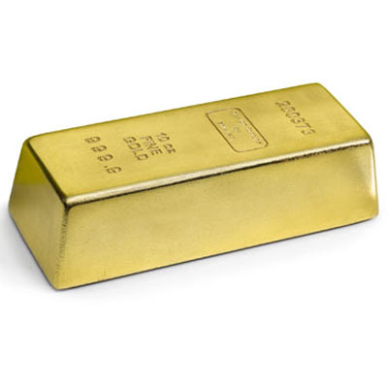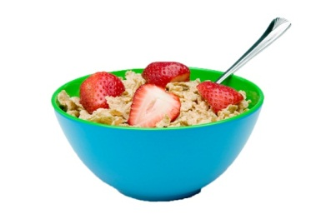

**Two Categories of Matter.**

* _______________________ are substances that

MATTER

are made up of only ______ type of matter.

(Ex. oxygen, water, gold)

* ___________________ are substances that are

Mixtures

Pure Substances

made up of __________________ types of matter

 which are mixed but not combined

chemically. (Ex. breakfast cereal)

**Pure Substances.**

* There are __________ types of Pure Substances:
  + ______________ are pure substances that _____________ be separated into simpler substances. (Ex. carbon, nitrogen)
  + 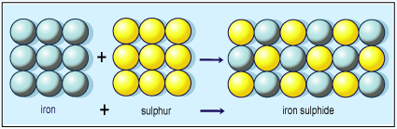______________ are composed of ________________ elements that are ________________. (Ex. water, ethanol)

**Mixtures.**

* **There are __________ types of Mixtures:**
  + **_________________** are when one substance is **_____________** in another substance. (Ex. sugar-water, salt-water)
  + **_________________** are when a fluid contains **________________** that will **_______________. (**Ex. milk, orange juice)
  + **__________________________** are when the parts of the substance can be _________________ out again. (Ex. raisin Bran, munchie mix)

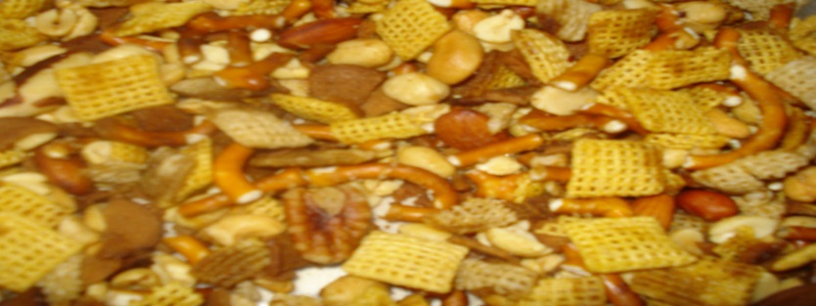

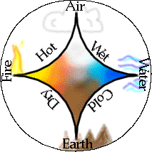**1.3 Atomic Theory.**

* _________________ believed that matter was made of

*______________* that were the smallest pieces of matter.

* _______________ believed matter was made of different

combinations of __________, ___________, __________ and ________________.

**Early Ideas About Matter.**

* ____________ experimented with matter and tried to turn common metals into _______.
* Their activities marked the beginning of our ______________________________.

**Atomic Theory #1.**

* ____________________ (1766 - 1844)
  + 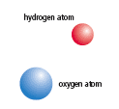Credited with developing a theory that was a _____________________________.
  + He studied _______ that make up _____________________.
  + Based on his studies, he suggested that:
    - Matter is made of small, hard spheres that are different

for different element.

* + - The smallest particle of an element is called an atom.

**Dalton's Atomic Theory.**

* 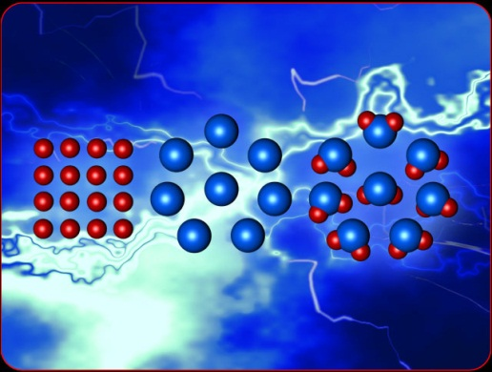All matter is made of _______________________________.
* Atoms ___________________________________

into smaller particles.

* All atoms of __________________________________,

but they are different in mass and size from the

atoms of other elements.

* ________________________ are created when atoms of
* different elements link together in ________________________.

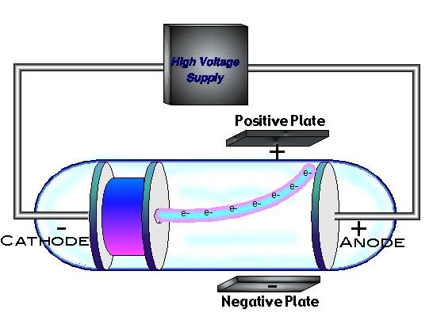**Atomic Theory #2.**

* ___________________ (1856 - 1940)
  + Thomson studied ____________________ in gas

discharge tubes (like today’s fluorescent lights). From

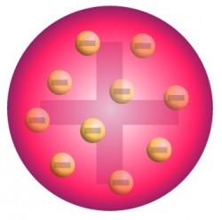his studies, he determined that the currents were streams of _______________________ particles. These were later called ____________.

* + He hypothesized that atoms are made of smaller particles. He proposed the “___________________” model of the atom.
  + This model is best visualized as a _________________________ with ________________________ spread out in it like raisin.

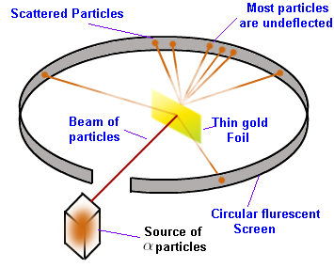

**Atomic Theory #3.**

* _________________________ (1871 - 1937)
  + After experimenting with charged particles, he

found that some particles were ____________

in directions ___________________________.

* + 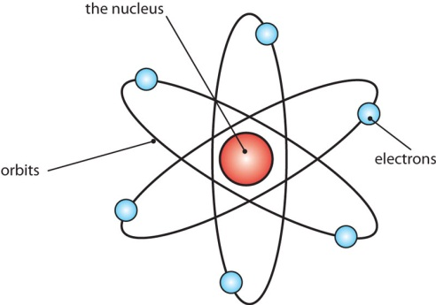He suggested that the deflection of the charged particles was because the atom contained

a ________________ called a ____________, and electrons moved around the nucleus.

**Atomic Theory IV**

* ________________ (1885 - 1962)
  + He studied gaseous samplesof atoms, which were made to ______ by passing an

______________ through them.

* + Based on his observations, Bohr proposedthat electrons surround the nucleus in specific “____________________” or “___________.”

**Inside the Atom.**

* An atom is the ______________________________________

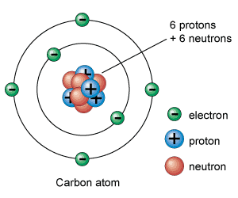_________________________________.

* All atoms are made up of three kinds of particles called

__________________________

. These particles are:

* + ______________
  + ______________
  + ______________