BC SCIENCE 8 - Chapter 5 Practice Booklet
Answer Section

COMPLETION

1) transparent

2) angle, incidence

3) normal

4) ray

5) angle, reflection

6) plane

7) convex lens

8) concave lens

MATCHING

9) E

10) A

11) B

12) D

13) B

14) B

15) E

16) C

17) A

18) D

SHORT ANSWER

19) The image looks twice as far away.

20) (a) any two of: mirror type, location of object, image characteristics
(b) dependent variables—image characteristics (e.g., size, attitude, location); independent variables—mirror type or location of object
(c) Repeat test with a different object.

21) Babies need to be very close to a mirror so they can focus. When at close range to a concave mirror, the baby's image will appear upright and larger.

22) Concave mirrors would make guests appear upside down and smaller if the guests are far away from the mirror. When they are close to the concave mirror, they would appear upright and larger. Convex mirrors would emphasize certain body parts (such as facial features), making your guests look comical. Combining concave and convex mirrors might shrink some parts of a person's body, while accentuating other parts.

23) Answers will vary, but should indicate that the mirror must be angled to reflect the overall scene. A convex mirror would reflect a larger area than a plane mirror.

24) Drivers looking into their rearview mirrors will see the backward printing on the vehicle behind them. The printing will appear reversed in the mirror, making it easier for the driver to read.

25) In regular reflection, all the normals related to light reflected from a smooth surface point in the same direction. The images created from regular reflections are clear.

In random reflection, the normals related to light reflected from rough surfaces will point in random directions, depending on exactly where the incident rays strike the surface. When light reflects off a rough surface, random reflection occurs and no image results.

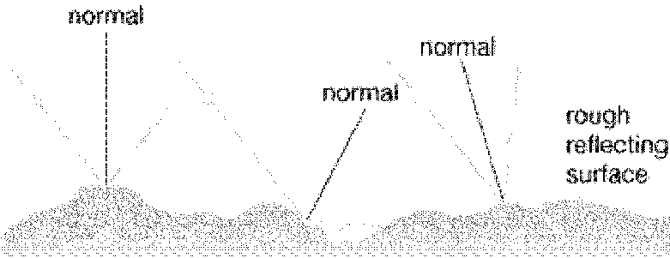

26) Convex lenses can be used to create a magnifying glass. If you place a flammable material (such as paper or bits of kindling wood) under your convex lens, the material will likely start to burn. Answers will vary, but may include any three of:

- exercise extreme caution when dealing with open flames
- keep your skin, hair, and clothing away from the flames
- tie back long hair
- build a ring of stones or use a metal pail to contain the fire
- have dousing material nearby

27) (a) twice the focal length; therefore, it is 5 cm
(b) smaller, in front of the mirror, inverted

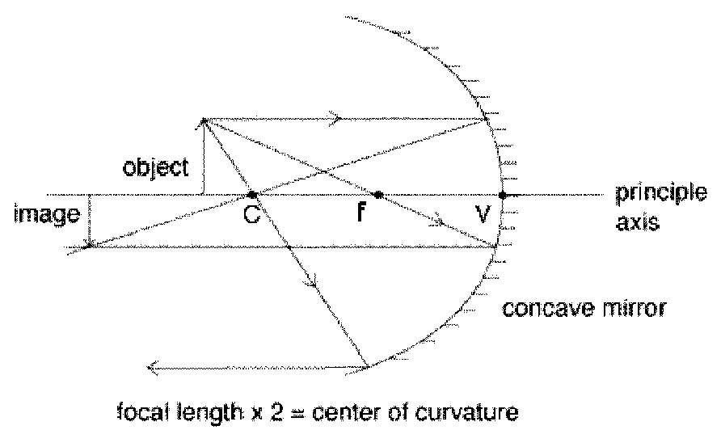

28) (a) ray diagram should include: incident rays, reflected rays, and imaginary image. Look for the image drawn smaller than object and behind mirror.
(b) characteristics include: the image is smaller, behind the mirror, and upright.

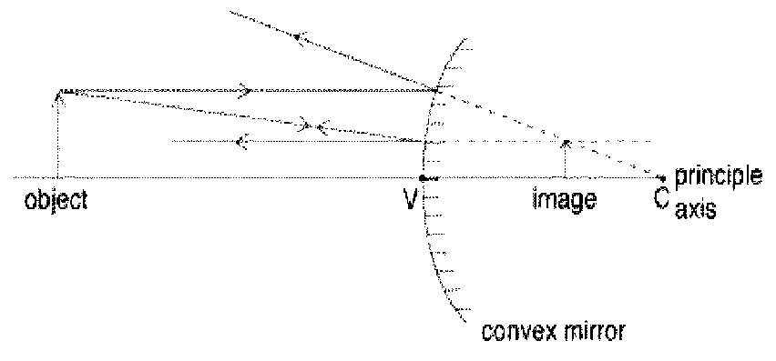

29) (a) ray diagram should include incident and reflected rays, the image size, location, and attitude
(b) image characteristics include: smaller, behind the mirror, and upright

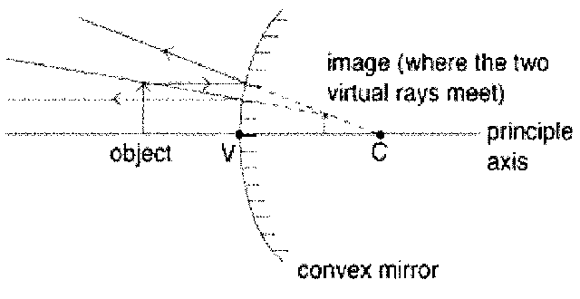

30) (a) ray diagram should include incident and reflected rays, the image size, location, and attitude
(b) image characteristics include: smaller, in front of the mirror, and upside down.

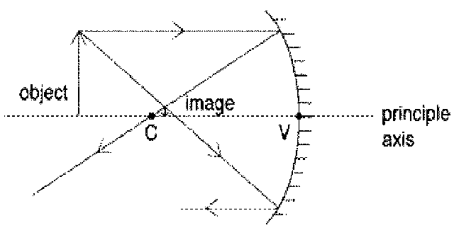

31) Both images should be inverted and smaller than the original image.

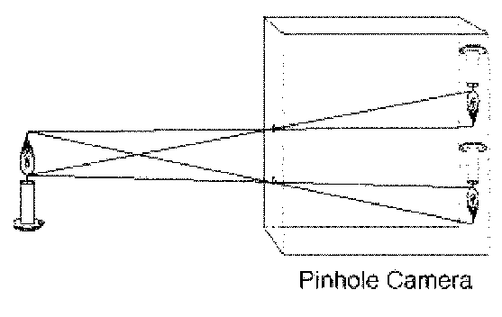

32) The image of the candle will be projected onto the back of the pinhole camera (film, screen, etc.), inverted, and larger than the actual candle.

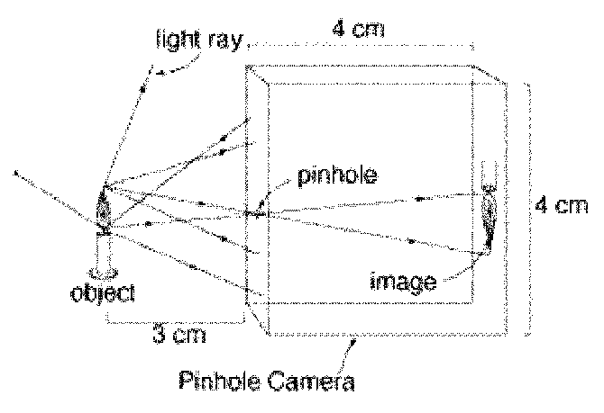

33) (a) ray diagram should include incident and reflected rays, the image size, location, and attitude
(b) image characteristics include: bigger, inverted, and in front of the mirror

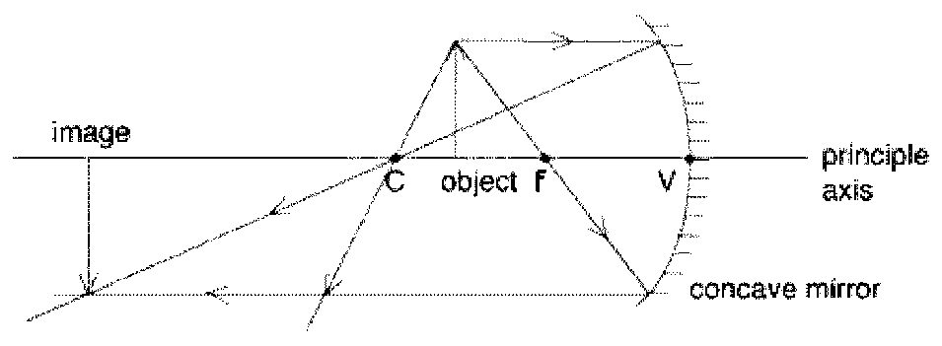

34) convex lens

35) (a) distance from mirror, amount of store seen
(b) amount of store seen
(c) distance from mirror

36) A flashlight has a concave lens. Concave lenses cause the light to spread out. At night, the flashlight would light up the area in front of it and a little bit of the periphery as light is transmitted through the lens.

37) A car headlight has a concave lens. The light bulb is near the principal focus. As the light travels through the lens, it diverges or spreads out. Headlights are needed at night to light up a road. The intensity of the light can be regular or high beam. The high-beam option allows for greater visibility because more light spreads out farther.

38) The angle of reflection is equal to the angle of incidence.

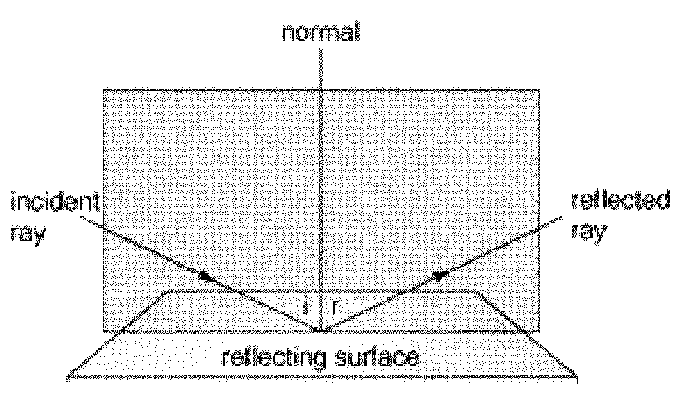

39) The audience watches the shadows cast on the translucent screen (some light passes through). The opaque puppets do not let any light pass through.

40) - translucent surface (e.g., wax paper): Some light passes through, but the light is scattered from its straight path.
- transparent surface (e.g., plastic wrap): All the light passes through.
- opaque surface (e.g., wood): No light gets through.

41) Answers will vary; for each mirror, accept any one of:
- concave: cosmetic mirror, telescope
- convex: sideview mirror on a car, security devices

PROBLEM

42) As light travels through the atmosphere, it is refracted by particles in the atmosphere. The light from the stars near the horizon must pass through more atmosphere and therefore is subject to more refraction.

43) - b
- 40°
- The angle of incidence is equal to the angle of reflection.

44) Mirages occur when air near the ground warms up, refracting the light from objects at a distance. This creates the illusion of a water surface, but it is really an image of the sky refracted onto the warm air near the ground.

45) Because the angle of incidence equals the angle of reflection (first law of reflection), you know that when you shoot the puck to bounce it off the boards, the angle at which you shoot it will be equal to the angle at which it will bounce off the boards. This knowledge will increase your accuracy when passing the puck.

46) The floor acts like a plane mirror. Because the angle of incidence equals the angle of reflection (first law of reflection), you can predict that the ball will bounce off the floor at the same angle (and in the opposite direction) as it approached the floor.

47) There are no particles in a vacuum. Light slows down in the denser environment of Earth's atmosphere. This is the principle of refraction.

