Name: ______________________________ Class: ____________ Date: ___________________

Student # : ______________________________ Mark: ____________ Percentage: _____________

BC SCIENCE 10 - Chapter 12 Practice Booklet

Matching

Match the correct term to each of the following descriptions. Each term may be used only once.

a) | focus | d) | subduction zone
b) | lithospheric plate | e) | mantle convection
c) | epicentre

____ 1) point on Earth’s surface directly above where an earthquake actually begins

____ 2) result of one plate diving beneath another plate

____ 3) flowing currents of material that help move plates across Earth’s surface

____ 4) portion of rock material that includes Earth’s surface

____ 5) point inside Earth where an earthquake actually begins

Match the correct term to each of the following descriptions. Each term may be used only once.

a) | spreading ridge | d) | lithosphere
b) | continental drift theory | e) | asthenosphere
c) | plate tectonic theory

____ 6) point on Earth’s surface where two plates are forced apart

____ 7) theory that Earth’s surface is broken up into large, solid, but moveable chunks of rock

____ 8) partially molten layer of the upper mantle

____ 9) theory that the continents were all once joined together but have moved to their present positions

____ 10) solid part of the crust and the upper mantle that forms tectonic plates

Short Answer

11) Explain how similar animal fossils in South America and Africa supported continental drift theory.

12) Explain how similar rock types and mountain ranges in South America and Africa support continental drift theory.

13) Explain the process of sea floor spreading.

Use the following graph to answer the next three questions.

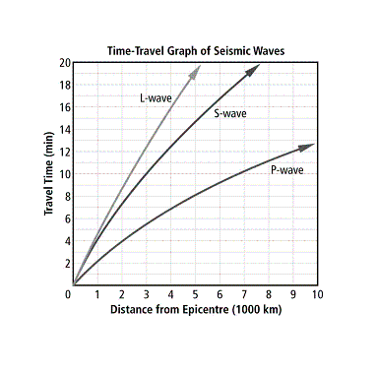

14) Why is the L-wave curve on the time-travel graph different than the curves for the S- and P-waves?

15) How long does it take an S-wave to travel 5000 km?

16) If the distance to the epicentre was 4000 km, how long after the P-wave would the S-wave arrive?

17) Why does subduction occur at certain types of plate boundaries and not at others?

18) Explain why volcanoes form at oceanic-continental plate boundaries but not at continental-continental plate boundaries.

19) Describe how earthquakes occur.

20) What are two possible geologic features that could result when two continental plates collide?

Problem

21) The oldest rocks on the continents are almost 4 billion (4 000 000 000) years old, while the oldest oceanic rocks are about 200 million (200 000 000) years old. Explain why there is this difference in age.

22) Glossopteris was a tropical fern that lived millions of years ago. Explain how the discovery of glossopteris fossils in Antarctica supports the idea of continental drift.

23) How do the physical properties of the lithosphere and the asthenosphere differ?

24) Why is the difference between the physical properties of the asthenosphere and the lithosphere important to plate tectonic theory?

25) Explain how convection currents occur in Earth’s mantle.

26) Describe what might happen if convection currents in Earth’s mantle were to suddenly stop.

27) Why are some volcanoes shaped like cones with very steep sides, while others are shaped like cones with gently sloping sides?

28) How are the locations of earthquakes and volcanoes related to plate tectonics?

Use the following map to answer the next two questions.

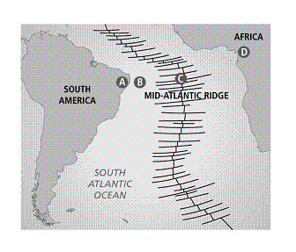

29) Describe two pieces of evidence suggested by the map above that South America and Africa were once together as one continent.

30) Point C on the map marks the location of the Mid-Atlantic Ridge. Explain why points A and D are equal distances from the ridge.

BC SCIENCE 10 - Chapter 12 Practice Booklet
Answer Section

MATCHING

1) C

2) D

3) E

4) B

5) A

6) A

7) C

8) E

9) B

10) D

SHORT ANSWER

11) Similar animal fossils found on now distant continents suggest that the animals once lived together on a large, single landmass.

12) Matching rock types and mountain ranges show that the forces that acted to create these features occurred when the rocks were in a common location, as part of a single, large landmass.

13) Magma comes up from the mantle and cools. New magma that is rising forces the old, cooled material apart, resulting in sea floor spreading.

14) L-waves travel along the surface and are therefore slower than P- and S-waves. This results in a different travel time (time/distance) curve.

15) 14.5 min

16) approximately 5.5 min

17) At a subduction boundary, a dense plate (oceanic) dives beneath a less dense plate (continental).

18) At oceanic-continental plate boundaries the oceanic plate subducts and melts, forming material for volcanoes.

19) Tectonic movement, meteor impact, and volcanic eruptions can all cause the earth to shake. Typically, earthquakes occur when there is a sudden release of built-up stress (usually caused by the movement of plates, as in convergence, divergence, and transform boundaries) along a fault in Earth.

20) Earthquakes, mountains, or faults could occur when two continental plates collide.

PROBLEM

21) Oceanic rock gets “recycled” at subduction zones, where it is melted in the mantle. Continental rocks do not get recycled as quickly and as a result have been in existence for longer.

22) Glossopteris is a plant that grows in tropical climates. Antarctica is an extremely cold climate. In order for glossopteris to have lived in Antarctica (and therefore for glossopteris fossils to have been found in Antarctica), the continent must have been in a warmer location than it is now (i.e., closer to the equator) and must have moved farther south since.

23) The lithosphere is solid, rigid, and broken up into large pieces called plates. The asthenosphere is made of partially molten material that flows.

24) Plate tectonic theory suggests Earth’s surface is broken into several solid but moving pieces called plates. Convection currents in the partially molten asthenosphere are the driving force of the motion of the solid lithospheric plates.

25) Convection currents occur in Earth’s mantle when rock material is heated by the decay of radioactive materials (isotopes). The rock material becomes less dense (i.e., magma), then expands and rises. As this material rises, cooler more dense material moves to take its place. When the rising material cools, it sinks, only to be reheated. The resulting circular motion is called a convection current.

26) Answers will vary but should include examples such as: the plates would stop moving; plate tectonics would stop; most earthquakes would cease; volcanism would stop (except at hot spot locations); and shield volcanoes at hot spots would be much larger because the plates would not be moving (e.g., Olympus, Mons, Mars).

27) Steep-sided volcanoes are composite cone volcanoes, which are made from thick magma that occurs at subduction zones. The thick magma does not flow easily and tends to accumulate close to the vent of the volcano, piling up and forming the distinctive cone shape. Gently sloping volcanoes are shield volcanoes made from thinner magma that forms at hot spots. The thin magma flows easily, and as a result, spreads out and away from the volcanic vent. Multiple eruptions lead to accumulations of layers that form the gentle slopes.

28) The vast majority of earthquakes and volcanoes form at the boundaries between plates, where plates crash into, slide past, or move away from each other. Magma reaches the surface at spreading ridges and subduction boundaries.

29) One piece of evidence is that the shape of South America and Africa suggests they were once part of a single continent. Another piece of evidence is that the presence of a spreading ridge between the two continents suggests they have been pushed away from each other.

30) The material rising at the Mid-Atlantic Ridge pushes each plate apart equally. When the original continent was together, the ridge split it apart and moved both pieces away at the same rate.

